Important note about next lecture

Please, don't forget!

The "Class library project" lecture was recorded after the entire course! As a result, it had all of the folders in the Solution Explorer. The next lectures such as the "Unit test project" were recorded in the normal sequence, so you will not see the entire layout of the solution. You will only see the project that is relevant to this section => **ClassLibraryPractice**

When you pull down the solution code from this class, you will see this:

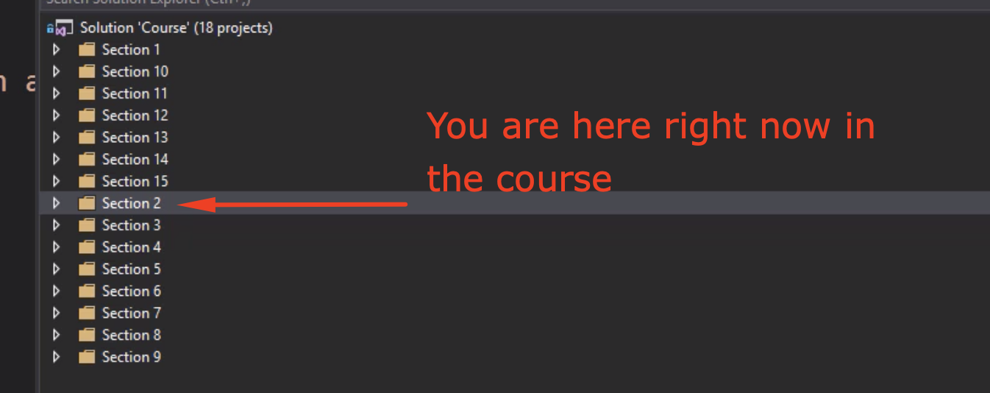

But in the videos for a few sections, you will see this:

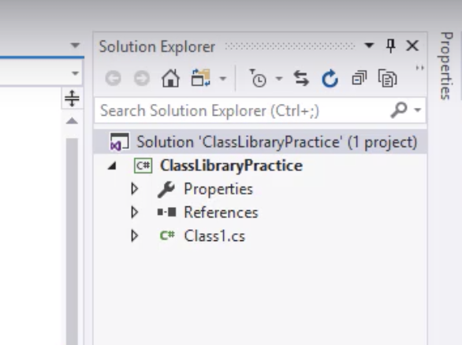

The reason for this is that we weren't wise enough to organize the solution in the right way at first. And then organized it after the videos were created. That way it's easier for you to follow.

If you want to follow along with the code from Github, just remember that each folder matches each section of the course. Currently, you are in Section 2 of the video course. That will match a folder called "Section 2" in the Github solution. Inside of that folder, in the solution, you will find the correctly named project that you see in the videos.

I hope that makes sense?? If not, please let me know and I will gladly clear up any confusion :)